Parks and Recreation

The City of Dahlonega operates and maintains six parks and public use areas and continues to grow to meet the passive recreational needs of our community and enrich leisure through a variety of resources. Lumpkin County, through our Service Delivery Agreement, provides active recreational and team sports opportunities to our community. Please visit their website for additional information.

Lumpkin County Parks and Recreation <https://www.lumpkincounty.gov/153/Parks-Recreation>

Pinetree Recreation Center <https://www.lumpkincounty.gov/491/Pinetree-Recreation-Center>

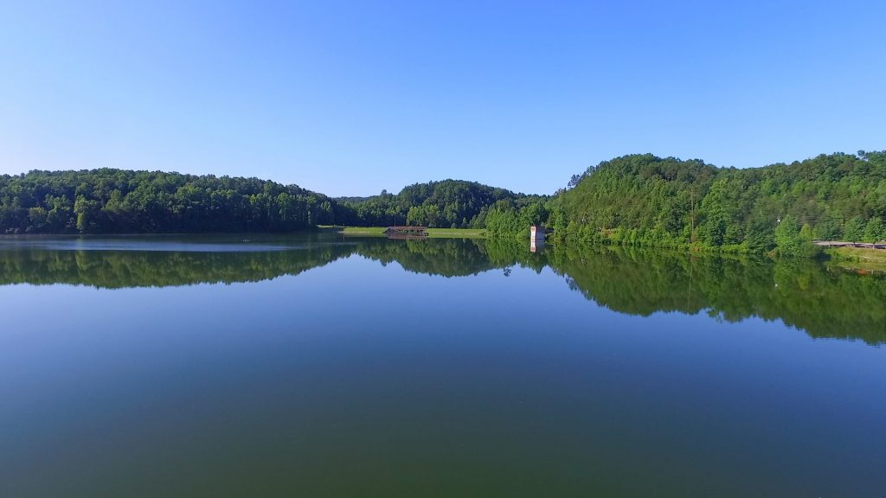

[Lake Zwerner and Yahoola Creek Reservoir](https://dahlonega.gov/parks-and-recreation/lake-zwerner-and-yahoola-creek-reservoir/)

<https://dahlonega.gov/parks-and-recreation/lake-zwerner-and-yahoola-creek-reservoir/>

Located just northeast of downtown along Morrison Moore Parkway East, Yahoola Creek Reservoir provides most of the City of Dahlonega’s water supply along with multiple recreational opportunities.

A parking area along the bypass provides easy access to the Lake Zwerner Dam and a circumnavigational hiking trail that creates a loop around the reservoir, approximately 3.2 miles in length.

Just north of the Hwy 60 bridge, one can find the Lake Zwerner boat ramp and dock, along with picnic facilities and fishing access.

*Yahoola Creek Reservoir is a drinking water reservoir, therefore, the following activities are prohibited:

• Wading, Swimming or Bathing  
• Littering or Dumping  
• Watercraft with gasoline powered motors  
• Discharge of any pollutant  
• Fishing, except in areas and hours specified by the City

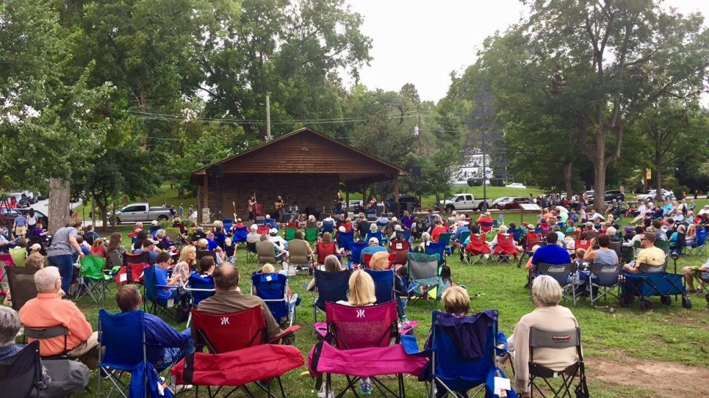

[Hancock Park](https://dahlonega.gov/parks-and-recreation/hancock-park/)

<https://dahlonega.gov/parks-and-recreation/hancock-park/>

Hancock Park is located just off Dahlonega’s Historic Square at the corner of North Park Street and Warwick Street. This spacious green space in the heart of downtown offers a place for residents and visitors to gather. It is used not only as a relaxing green space but also as a pavilion that is used for downtown events and festivals. The [First Friday Night Concert Series](https://www.facebook.com/DahlonegaFirstFridayConcert) and the [Dahlonega Farmers Market](https://www.facebook.com/DahlonegaFarmersMarket) are held in Hancock Park annually May through October.

Visitors interested in the unique history of Dahlonega are encouraged to visit Hancock park to view the Maibaum Tree and the [Chestatee Diving Bell](http://www.lumpkinhistory.org/events/chestatee-diving-bell).

Please contact Downtown Development Authority to check the availability of renting the pavilion for your special event.

Link to Hancock Park rental form:

The Dahlonega Gold Mine All-Abilities Playground

The Dahlonega Gold Mine All-Abilities Playground is the latest addition to Hancock Park. The 2,800 square feet play area features play structures which are not only unique to the Northeast Georgia region, but also to the Southeastern United States as well. The Dahlonega Gold Mine Playground celebrates our natural history with a six-foot mine shaft climbing structure painted to resemble the rocks found in actual Dahlonega-area gold mines. The soft Poured-in-Place rubber matting is colored to resemble a river flowing through a grassy area. Children can climb on a bear cub and leaping trout sculpture pieces or swing on one of two Cloud 9 Swings while their parents sit on nearby benches or on the small retaining wall facing the Hancock Park Pavilion. Charlotte’s Web climbing structure will challenge children while they play as will the steppingstones and linkin’ log. The Dahlonega Gold Mine All-Abilities Playground also features three Freenote Outdoor Musical Instruments that are designed to enhance physical and mental development through the exploration of sound. These instruments, like the sculptures and swings in the Playground are accessible to children with physical and developmental handicaps. Only the simplest motor skills are needed to activate pure harmonies and melodies, ensuring musical success for all players.

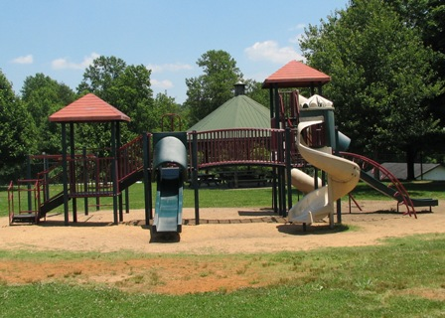

[City Hall Park](https://dahlonega.gov/parks-and-recreation/city-hall-park/)

<https://dahlonega.gov/parks-and-recreation/city-hall-park/>

City Hall Park features two large pavilions with picnic tables, two children’s play areas, two swing sets accommodating both infants and children, a paved walking loop all contained inside a fenced area and conveniently located at 465 Riley Road next door to City Hall.

The pavilions can be reserved for special events for a fee. To check availability please contact City Hall. Reservations must be made in person.

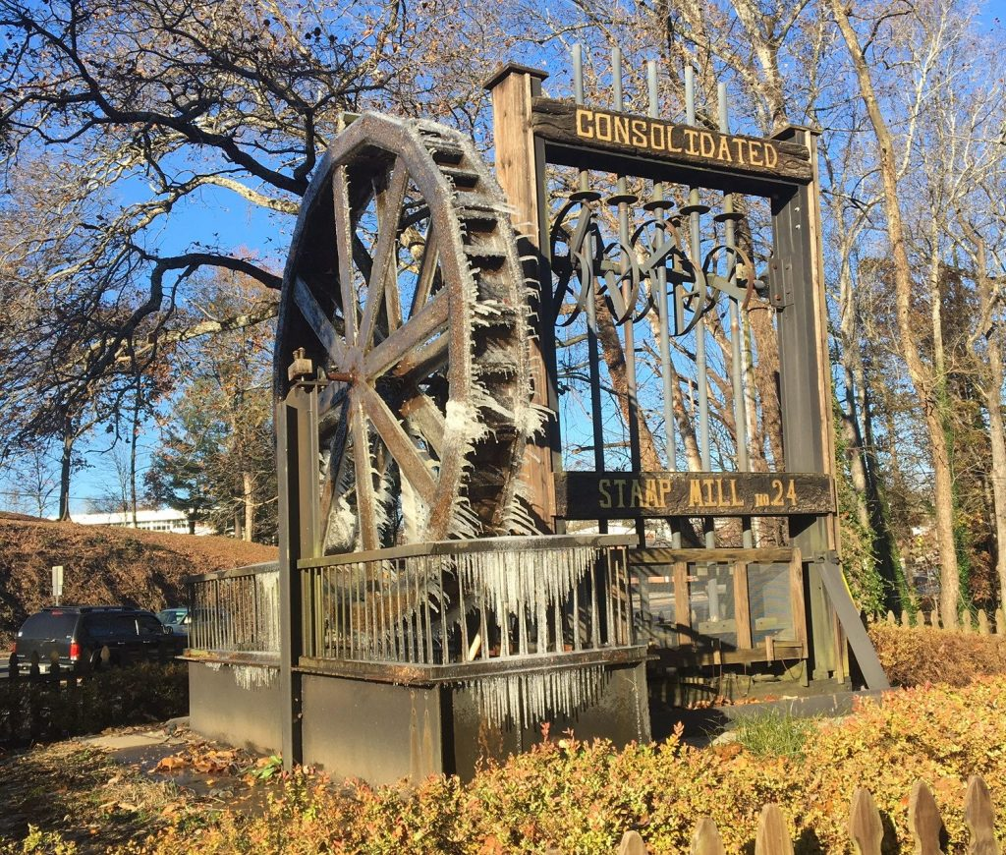

[Madeleine K. Anthony Park](https://dahlonega.gov/madeleine-k-anthony-park/)

<https://dahlonega.gov/madeleine-k-anthony-park/>

Madeleine K. Anthony Park is located at the corner of South Chestatee Street and Morrison Moore Parkway.  This park was named for Madeleine K. Anthony for her historic preservation and tourism development efforts along with her dedicated public service to the City of Dahlonega, Georgia.

The park features a public pavilion with picnic tables and fireplace, an operational historic stamp mill and waterwheel, beautiful trees and flowering bushes. Public parking is available on both South Chestatee Street and South Park Street.

Wimpy Mill Picnic Area

Located on Wimpy Mill Road, the Wimpy Mill Picnic Area was created in 2021 as a place for quiet reflection and passive recreation opportunities overlooking the reservoir. The picnic area has picnic tables, benches, and an accessible kayak launch area. Public parking is available.

Conner Memorial Garden

Conner Memorial Garden was purchased by the City of Dahlonega in 2024. Located just off the Public Square at the corner of North Chestatee St. and Warwick St. this pocket park offers various ornamental and pollinator plantings, benches, a lending library, and has water feature.